



Easy-Learn

Education Portal University

Supervised by

Asst. Prof. Dr. Amira AlShazly

Faculty of Computers and Data Sciences,

Alexandria University.

November 2023

**Project Name**

**Education Portal**

**Team Members**

|  |  |  |
| --- | --- | --- |
| Name | ID | Role |
| Alia Medhat | 20221440735 | Web Developer |
| Mohamed Gomaa | 2103129 | System Designer |
| Malak Mahmoud | 20221445867 | System Analyst |
| Nouran Mohamed | 20221321932 | Requirement Engineer |
| Noha Nael | 2103130 | System Designer |
| Youssef Farouk | 20201310051 | Web Developer |

**Table of Contents**

1. Project Domain 6

2. Project Name and Type 6

3. Project Description 6

4. The Delivery Service for the Customer 6

5. Functional Requirements 6

5.1. Student Management (Login-Sign Up) 6

5.2. Course Management (Manage/View Courses) 6

5.3. Exercises and Grading 6

5.4. Search and Navigation 6

6. Non-Functional Requirements 6

6.1. Performance 6

6.2. Security 6

6.3. Usability 7

6.4. Compatibility 7

6.5. Maintainability 7

6.6. Scalability 7

7. Agile Requirements 7

8. Glossary 7

9. Prioritized Requirements 7

10. Assumptions and Constraints 7

11. Verification 7

12. Diagrams 8

12.1. Sequence Diagram 8

12.2. Activity Diagram 10

12.3. Class Diagram 11

12.4. ERD 12

12.5. Use-Case Diagram 13

13. Interfaces 14

13.1. Student Interfaces 14

Student Login 14

Student Register 14

Home panel 15

Courses Panel 15

Exercises 16

Download 16

About Us 17

13.2. Admin Interfaces 17

Admin Login 17

Administrator panel 18

Manage Courses 18

Add Exercises 19

Display and search for students 19

Manage and add admins 20

**Table of Figures**

Figure 1: Student Sequence Diagram 12-1 8

Figure 2: Admin Sequence Diagram 12-1 9

Figure 3: Activity Diagram 12-2 10

Figure 4: Class Diagram 12-3 11

Figure 5: ERD 12-4 12

Figure 6: Use-Case Diagram 12-5 13

# Project Domain

Platform for education portal.

# Project Name and Type

* Project Name: ‘Easy-Learn’.
* Project Type: Education Portal Website.

# Project Description

The project aims to create a user-friendly educational portal that multiple universities can utilize. This platform will provide an easy-to-use interface for students, offering a variety of courses, interactive content, and quizzes. The focus is on simplicity to ensure students from different universities can access educational materials effortlessly.

# The Delivery Service for the Customer

Easy-Learn provides a user-friendly educational portal for learning and teaching. Students will gain convenient access to a wide range of educational content, interactive courses, and the flexibility to learn at their own pace. Easy-Learn also enable students to enhance their academic skills and pursue their educational goals.

# Functional Requirements

## Student Management (Login-Sign Up)

* Student shall be able to create accounts.
* The system shall have a secure login and password recovery.

## Course Management (Manage/View Courses)

* Admins shall be able to create and manage courses.
* Students shall be able to view courses.
* Admins shall be able to upload text, video, and interactive content.

## Exercises and Grading

* Admins shall be able to create exercises for every course.
* The system shall automatically grade and gives feedback.
* Students shall be able to view their performance on the course.

## Search and Navigation

* Students shall be able to search for courses and materials.
* The system shall be customizable interface with quick access to courses.

# Non-Functional Requirements

## Performance

* The system shall have acceptable response times for different actions.
* The system shall handle increasing numbers of students and content.
* The website shall be available and reliable.

## Security

* The system shall encrypt all sensitive data.
* The system shall compliance with data protection regulations.
* The system shall implement role-based access control.
* The student shall authenticate themself with their given email address in the registration phase.

## Usability

* The website shall be easy to use and navigate for students of all skill levels.

## Compatibility

* The system shall be compatible with popular web browsers.
* The system shall be compatibility with different operating systems.

## Maintainability

* The system shall use version control tools for code management.
* The document shall maintain detailed documentation for the project.

## Scalability

* The system shall handle a growing in students base.

# ****Agile Requirements****

* The e-learning website will be developed using an agile methodology. This means that the requirements will be prioritized and implemented iteratively, with feedback from stakeholders being gathered throughout the development process.

# Glossary

The following terms are used in this SRS document:

* Course: A collection of learning materials and activities on a specific topic.
* Admin: A person who creates and manage courses.
* Student: A person who interacts with the e-learning website.

# Prioritized Requirements

The following **functional requirements** have been prioritized for the initial release of the e-learning website:

1. Student management
2. Course management

The following **non-functional requirements** have been prioritized for the initial release of the e-learning website:

1. Performance
2. Security
3. Usability

# Assumptions and Constraints

The following assumptions and constraints apply to the e-learning website project:

* The website will be hosted on a cloud-based platform.
* The website will be developed using open-source technologies.
* The website will be initially developed for use on desktop and laptop computers.

# Verification

The following methods will be used to verify that the e-learning website meets the requirements:

* Unit testing
* Integration testing
* System testing
* User acceptance testing

# Diagrams

## Sequence Diagram

Student Sequence Diagram

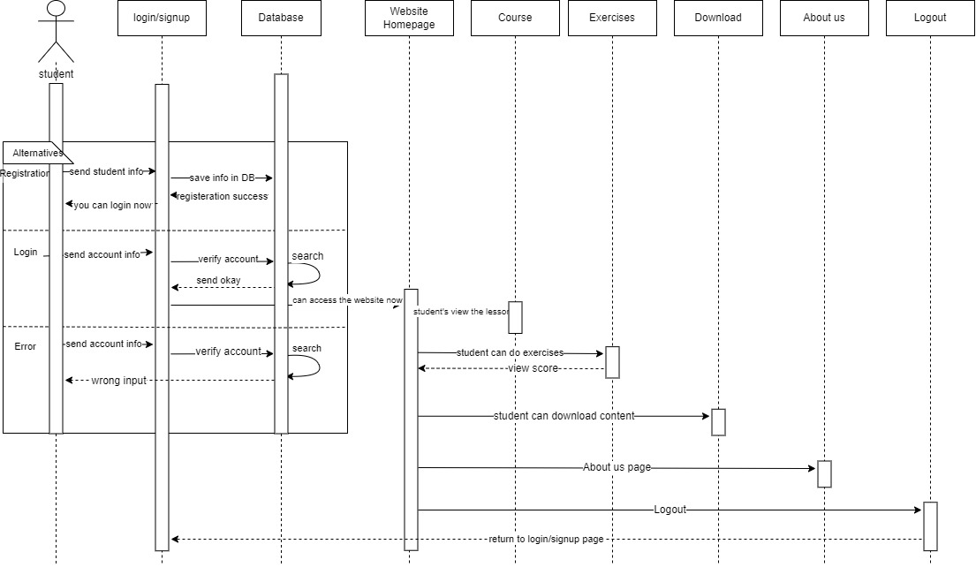

Figure 1: Student Sequence Diagram

Admin Sequence Diagram

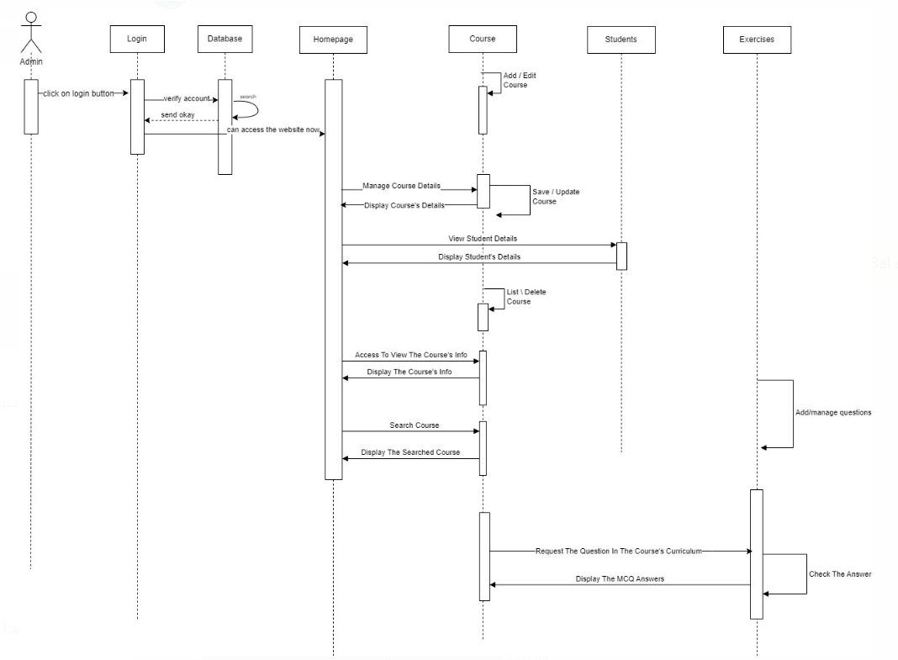

Figure 2: Admin Sequence Diagram

## Activity Diagram

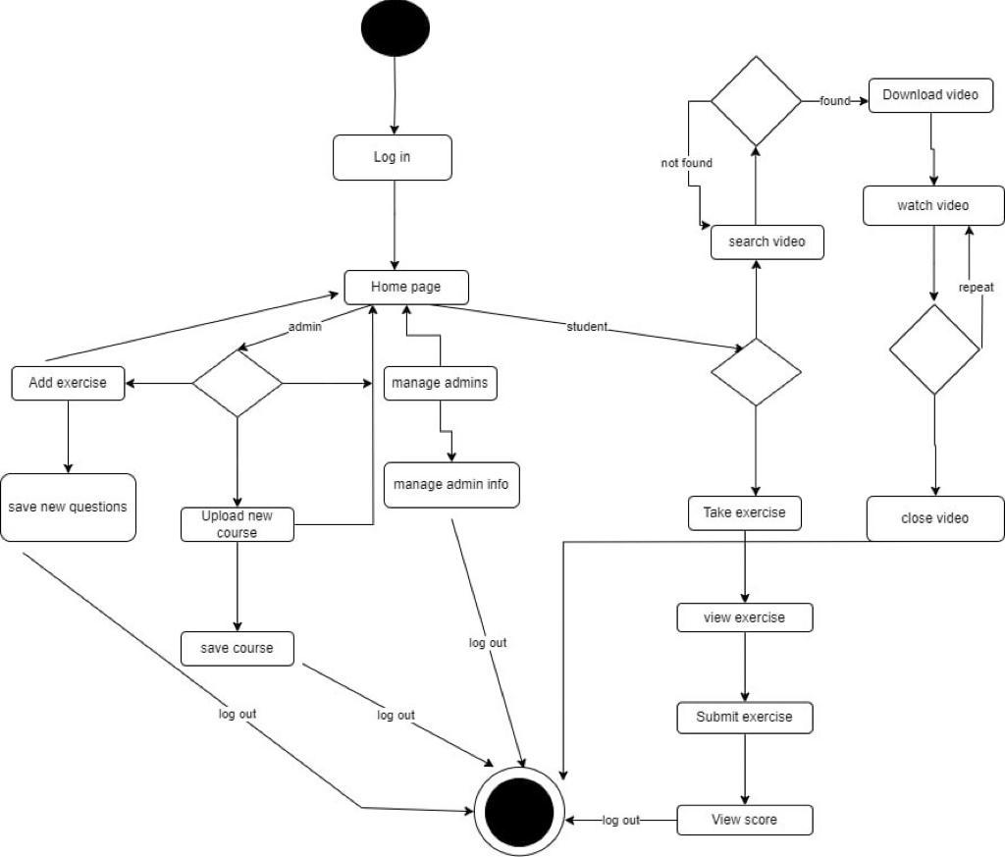

Figure 3: Activity Diagram

## Class Diagram

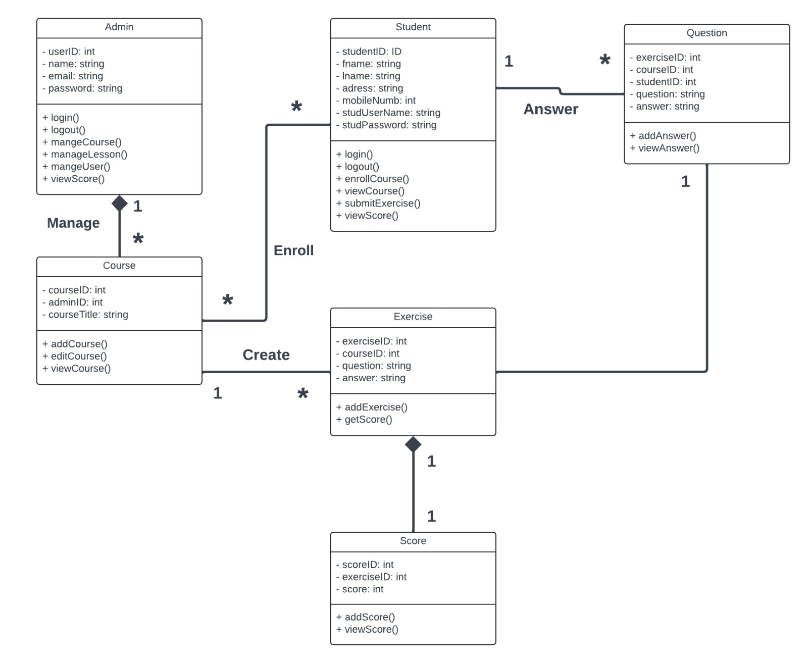

Figure 4: Class Diagram

## ERD

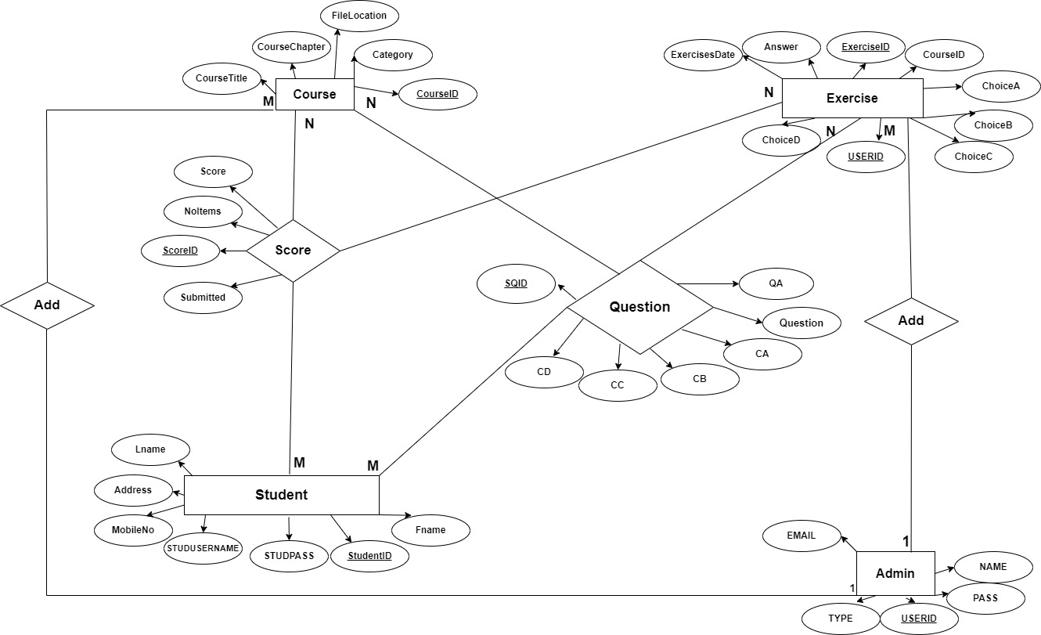

Figure 5: ERD

## Use-Case Diagram

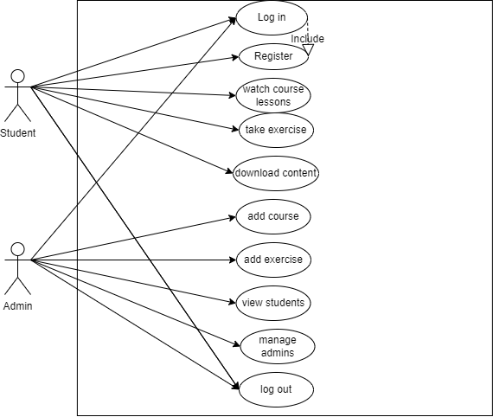

Figure 6: Use-Case Diagram

# Interfaces

## Student Interfaces

### Student Login

Students can login with their username and password if they already have an account.

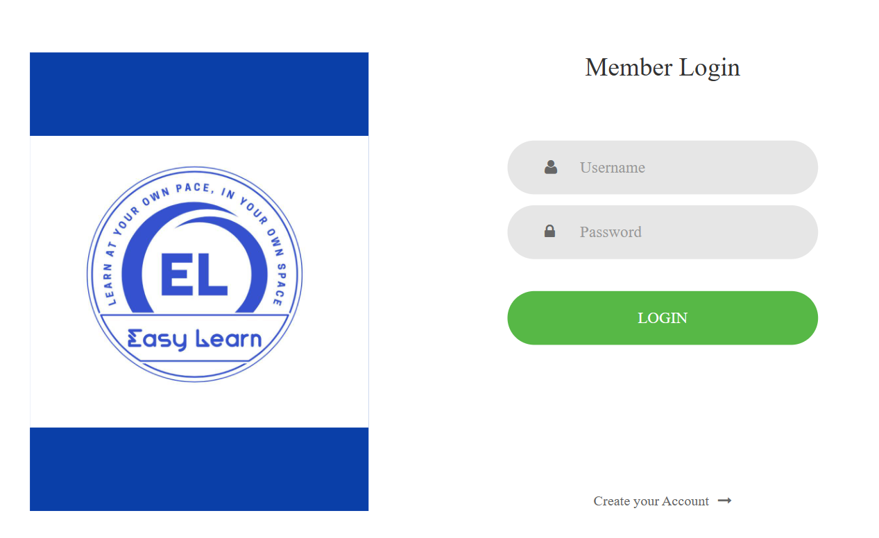

### Student Register

Students can create new accounts.

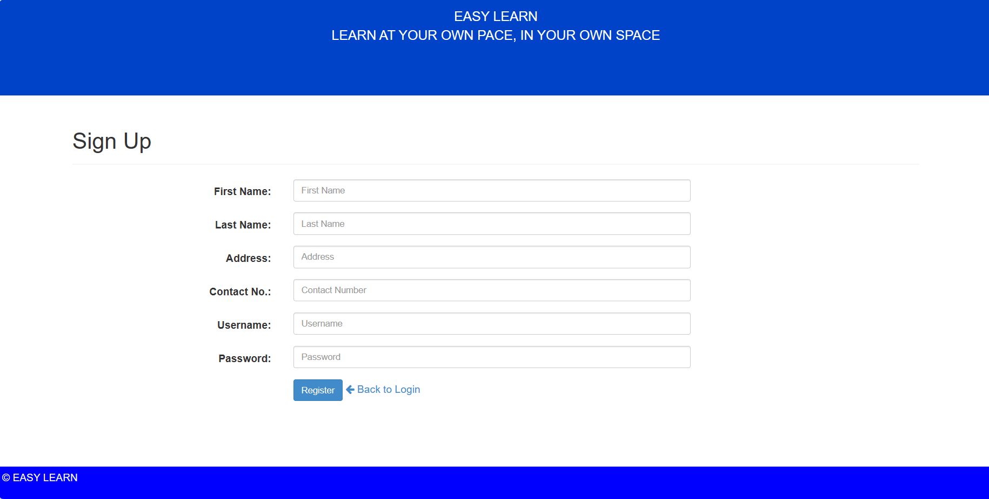

### Home panel

Our Home panel includes our websites objectives and goals, and from it students can access the courses and download content.

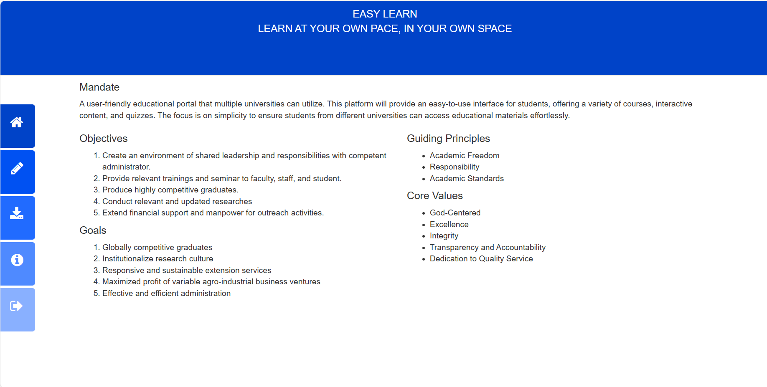

### Courses Panel

Students will be able to view and search courses.

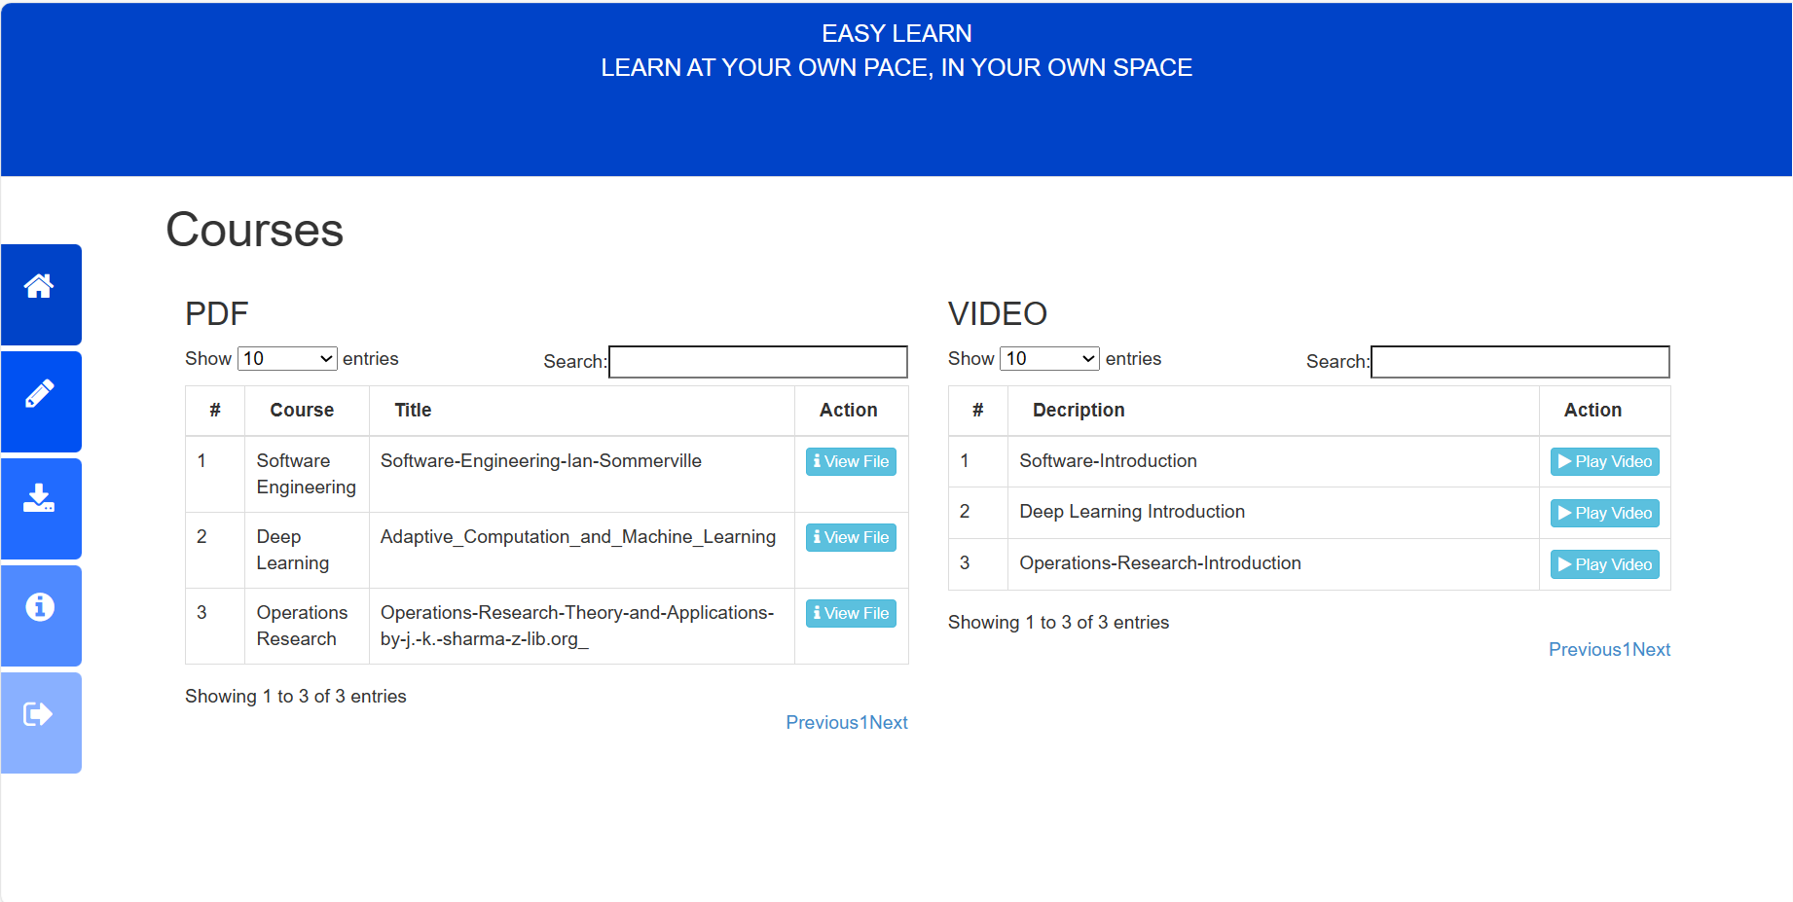

### Exercises

Students will do exercises and the system automatically will grade the student’s answers and gives feedback, also they will be able to view their grade.

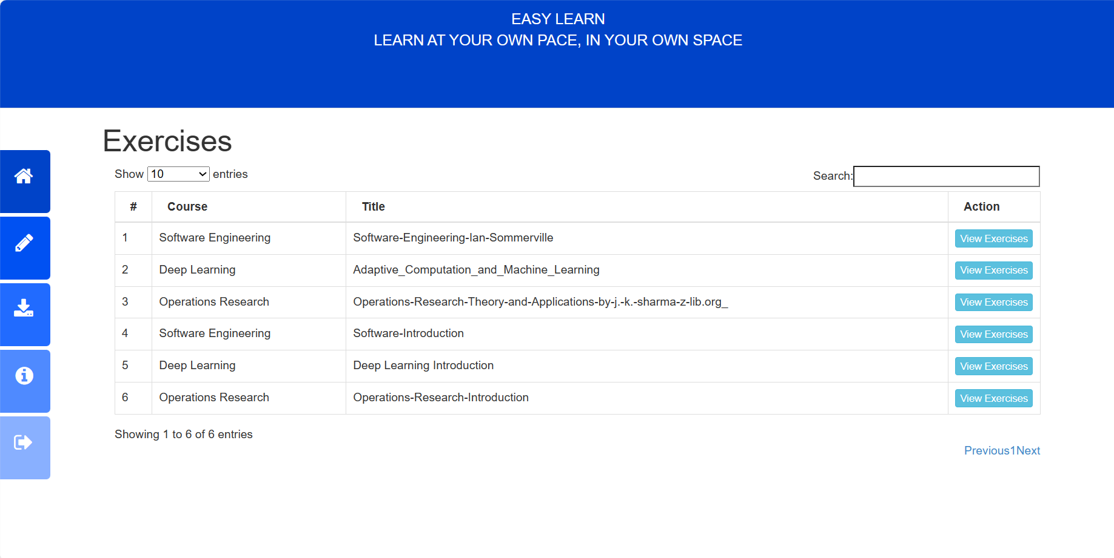

### Download

Students can download course content.

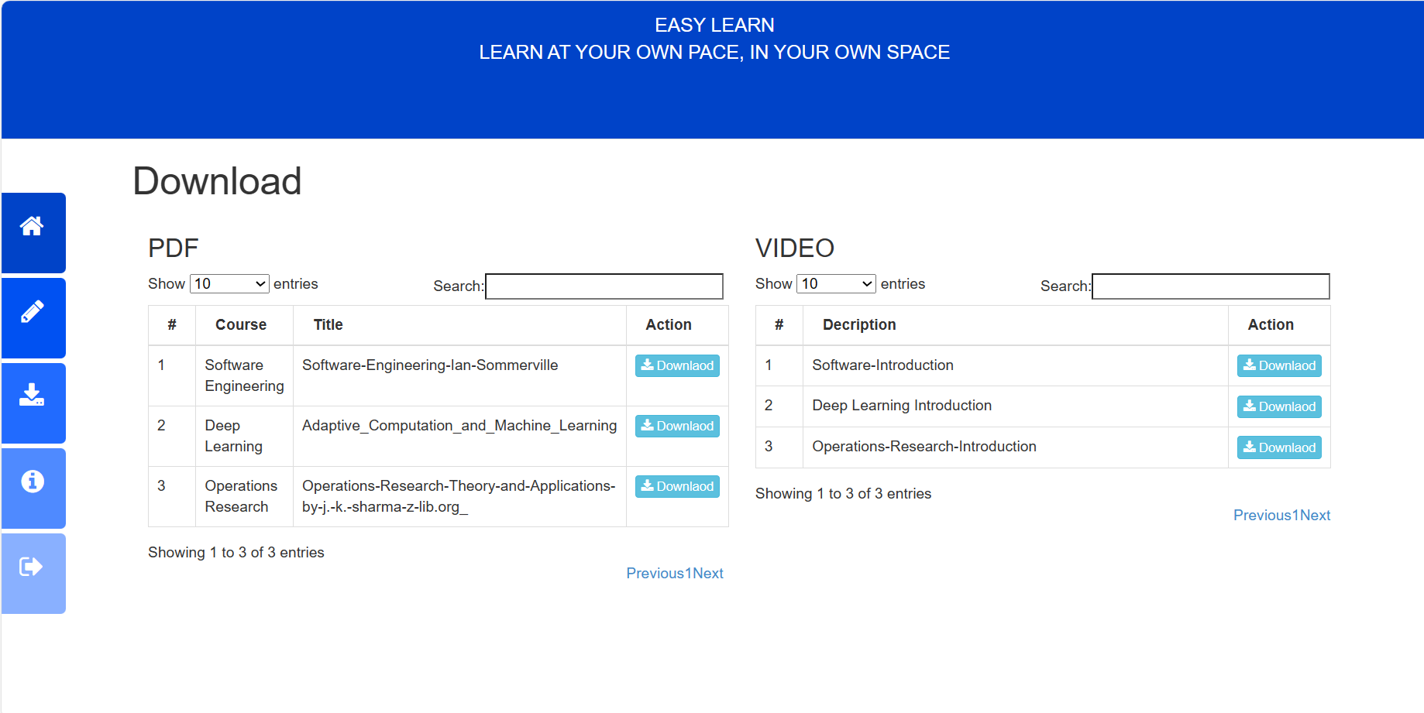

### About Us

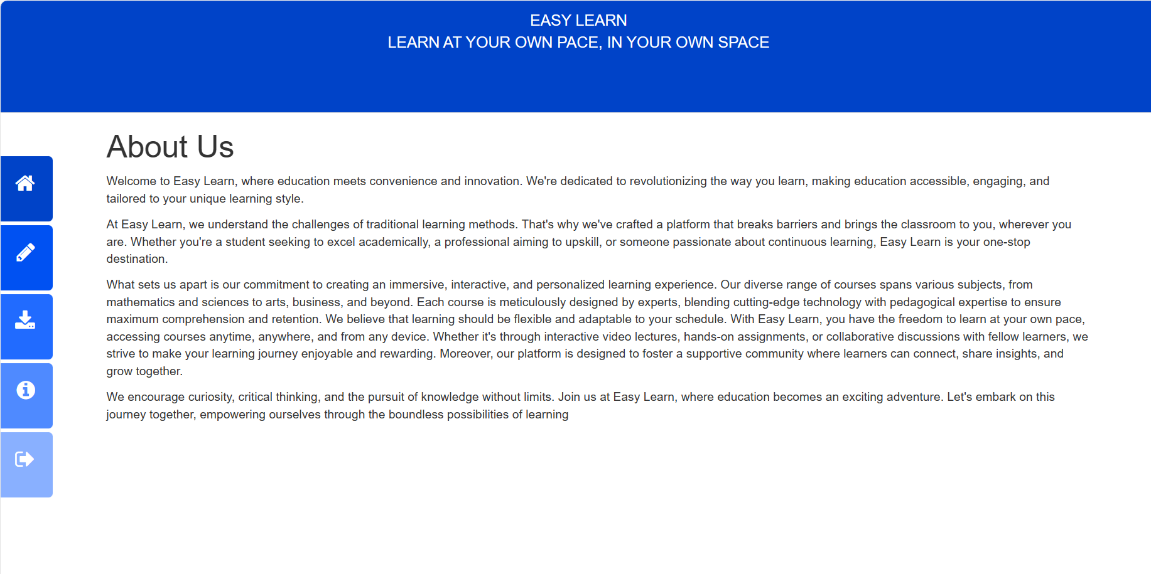

## Admin Interfaces

### Admin Login

To allow admins to access his/her account, and to verify the account

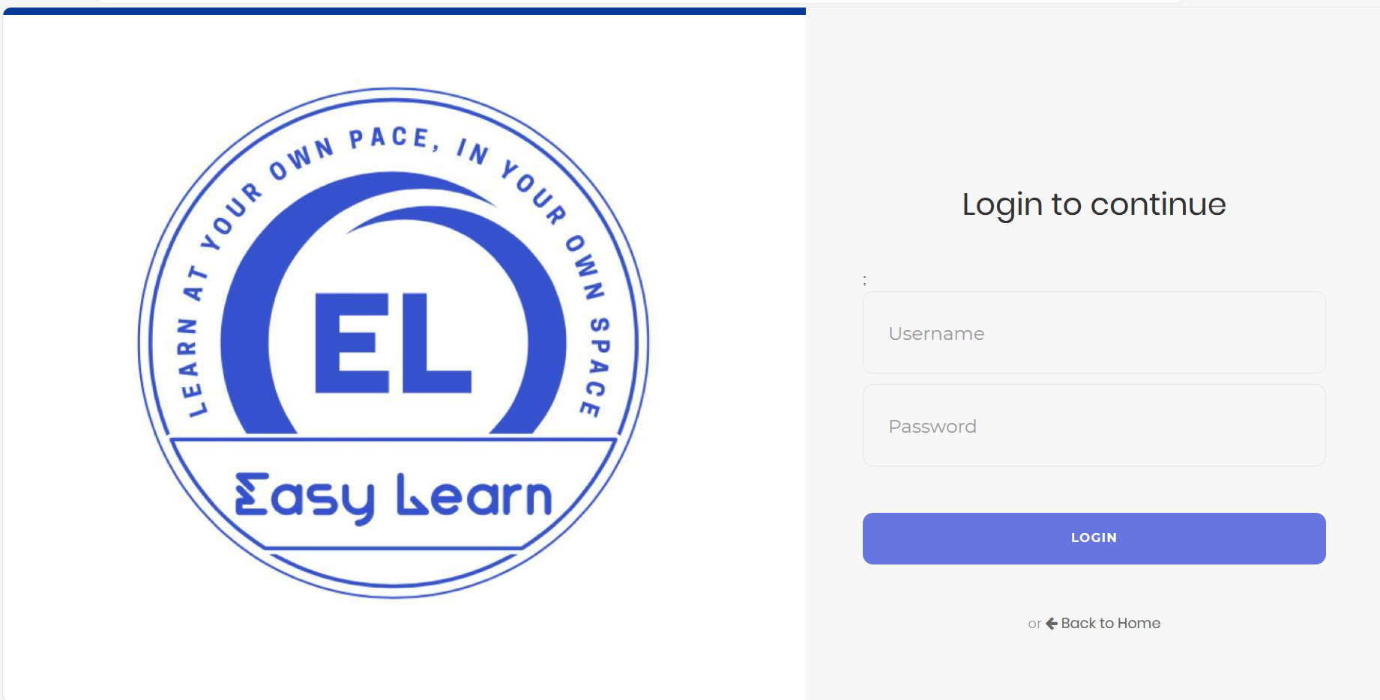

### Administrator panel

Display page of the actions that the admin can do

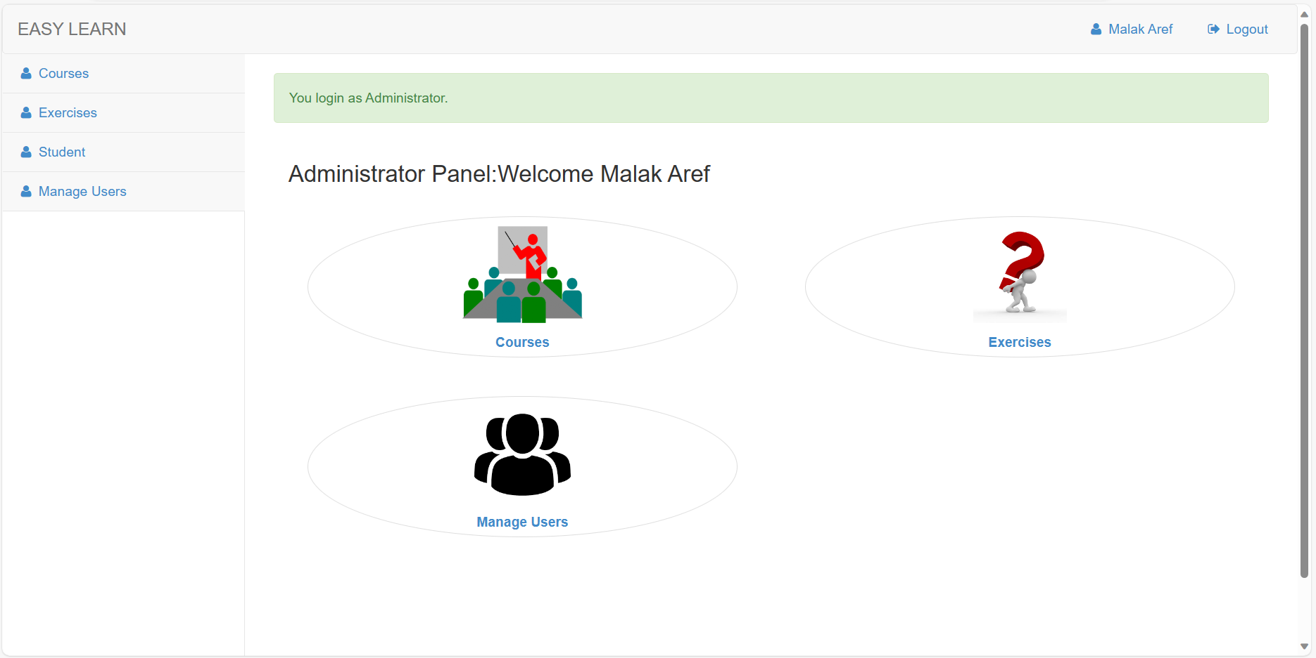

### Manage Courses

Admin here can create different type of courses. Also, he can manage, edit, delete, and change the course info.

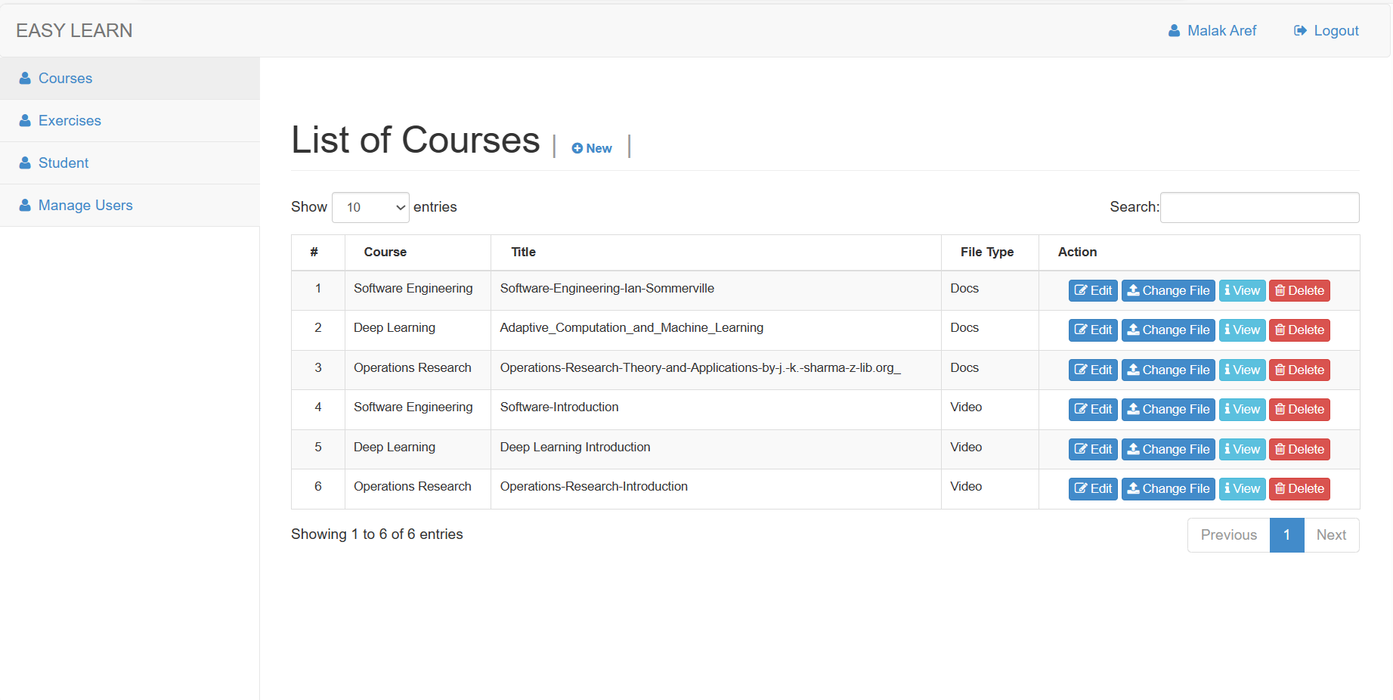

### Add Exercises

Admin can create and manage exercises for every course.

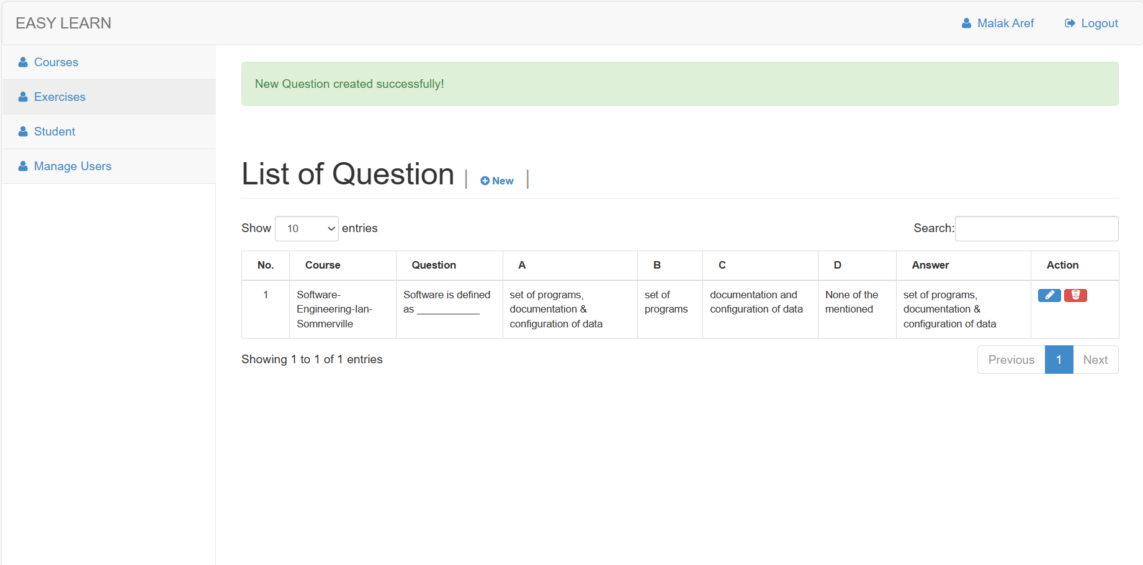

### Display and search for students

Display all the users that the system has.

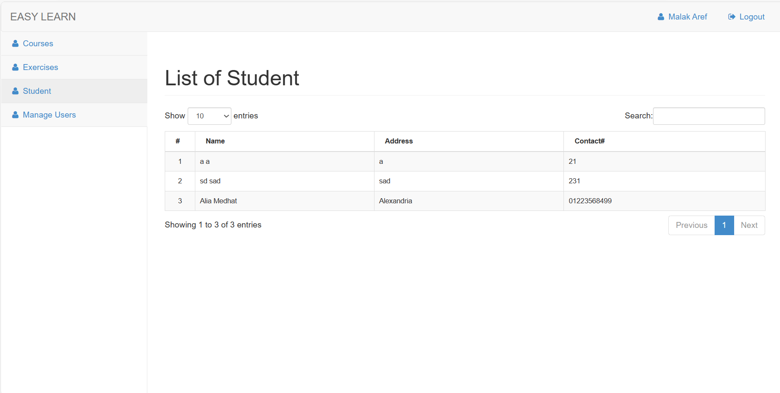

### Manage and add admins

Admin can add other admin and manage their info.

